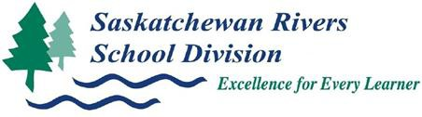
Kindergarten Year Plan Template

Time Frame  (months or weeks) | Possible Cross- curricular Focus | Arts Education | ELA | Health | Mathematics | Phys Ed | Science | Social Studies | Invitations | Resources | Division/Ministry Assessments
 |  | Focus Outcomes – Remember outcomes will/may be revisited throughout the year.

Where to Get Ideas for Resources:
*Curricular Core and Additional Resources
* SRPSD Helpful Resources
*Arts Education Invitation Ideas
*ELA Invitation Ideas
*Science Invitation Ideas
*Social Studies Invitation Ideas
*TRC Resource Lists

