Kindergarten Interdisciplinary Nov-Dec UbD Unit

Title of Unit | Interdisciplinary Nov.– Dec. UBD Unit
Time Frame | 6 weeks - November
Developed By
School
Identify Desired Results (Stage 1)
Content Standards –Curricular Outcomes
English Language Arts  CCK. 2 – Use and construct symbols, pictures, and dramatizations to communicate feelings and ideas in a variety of ways.  c) use language cues and conventions to construct and communicate meanings (manipulate sounds, explore sounds and rhymes)  g) demonstrate knowledge of upper and lower case letters.  CCK.3 – Use oral language to converse, engage in play, express ideas and share personal experiences  CRK.3 - Listen, comprehend, and respond to gain meaning in oral texts.  a)Listen attentively to others and respond appropriately.  d) Follow simple directions correctly and independently  CRK.4 - Comprehend, retell, and respond to basic ideas in stories, poems, songs, and informational texts read to them.  - Demonstrate awareness that communication can occur through visuals and print texts (including First Nations and Métis texts).  - Use strategies to construct and confirm meaning when “reading”:  - make connections to background knowledge (before)  - identify important ideas and events (during)  - recall (after).  - Understand and apply language cues and conventions to construct and confirm meaning when viewing, listening, and “reading”:  - show curiosity in words and their sounds (lexical/semantic)  - develop phonological awareness (graphophonic)  - recognize how gestures and body language communicate part of the message (other cues and conventions).  - Demonstrate an interest in and knowledge about books and reading.  - Know where to look for the title and author/illustrator.  - Choose to read or look at books, and demonstrate knowledge of print, reading-like behaviours, and book-handling skills.  - Demonstrate awareness that print is a permanent way of recording ideas.  - Create play situations from basic understandings of story text.  - Explain the main idea.  - Relate personal experiences, and represent responses through drama, physical movement, music, drawings, and models.  Science  NSK.1 Natural Surroundings - I can explore and discover changes to my surroundings (soil, water, landform and weather) over time.  I can ask good questions like “Where did the rain water go?”, “Why is some snow harder than other snow?”, and “Is a grain of sand a rock?”  I can use my senses and technology to collect and record information.  I can describe and illustrate things like temperature, wind direction and speed and humidity, presence of water, and landforms such as grassy, rocky, forest, and cultivated fields.  I can Identify, with guidance, changes in one or more aspects of my natural surroundings over time. (e.g., changes in temperature over a day and a week, changes to a tree over a year, changes in soil in a garden or flower bed over two seasons).  I can see that people change our natural surroundings. (e.g., building houses, mowing lawns, cutting down trees, planting gardens, damming streams, and digging ditches).  Health  USCK.3 Who Am I?  I know that I am more than just a body. I am learning that I have feelings and ideas that other people can’t see.  Social Studies  Outcome: DRK.3 - Analyze ways in which place and physical systems influence daily life, including the influence of place on the daily life of First Nations and Métis people.  - Name, and describe the physical characteristics of, the four seasons.  - Give examples of how daily life is influenced by environment (e.g., work, play, clothing).  - Identify how weather affects everyday life, and describe how adaptation for seasonal change is evident in daily life (e.g., clothing, food, home construction, recreational and sporting activities, transportation).  - Investigate ways in which place influences identity (e.g., leisure activities, sports, arts, and culture are all influenced by place).  Arts Ed.  Music  CPK.3 - Create sound compositions exploring the elements of music including:  - repeating patterns  - beat (e.g., clapping and stepping, and counting)  - response to fast/slow paces  - high/low sounds  - loud/soft sounds  - sounds with distinct tone colours/timbres.  I can hear and create music.  I can create repeating patterns with music.  I know the difference between speaking, shouting and singing.  Drama  Outcome: CPK.2 Explore a variety of drama strategies including:  - role  - imaging  - parallel play  - journeys  - meetings.  - Use sources such as stories, poems, observations, visual images, music, sounds, or objects to initiate drama work.  - Ask questions to contribute to inquiry on a drama topic (e.g., What might happen to animals if winter did not come this year? What if a messenger came to tell us that a giant was seen outside the town?).  - Listen to others and work co-operatively in dramatic contexts.  - Use imagination during, and when reflecting on, the drama experience.  - Listen quietly during imaging activities and become aware of thoughts and feelings that cannot be seen.  - Focus attention on own work, while respecting others, during parallel play and imaginary journeys.  Math  N.K. 1 I can count by 1’s from 0-10 and from 10-0  I can tell you which number comes before or after a number. (Rote Counting)  NK.2 I can recognize and name familiar arrangements of 1-5 objects, dots or pictures.  I can look and tell you the number of things on the table without counting. (1-5 objects) Subitizing  I can match a number with an arrangement of objects. Cardinality  NK.3 I can count 0-10 objects.  I can construct or draw a set of objects corresponding to a given numeral.  I can identify the number of objects in a set.  I can hold up the appropriate number of fingers for a given number.  I can match numerals with pictures.  NK.4 I can show a number in two parts using my fingers, counters or other objects and I can name the number in each part.  NK.5 I can construct a set to show more than, fewer than or as many. I can use words to describe it. |  |  |  | - ABC Museum  - Letter Search (sand table)  - Tack letters  - Journals  - Shared writing  - Circle  - Learning Centres  - Meal time  - recess  - Story time  - Reading Buddies  - Library  - Transitions  - P.Ed  - Circle  - Arts and crafts  - Book Browsing  - Reading Buddies  - Library  - Dramatic Play Centre  - Journal  - Science/weather centre  - Math Centre  - Literacy Centre  - Block Centre  - Mail Centre  - Science/Weather Centre  - Ipad/ Ipod  - Season Tree  - Dress for the weather activity  - Seasonal picture sorting game  - Water/Sand Table  - Circle  - Dramatic Play area  - Journal  - Puppets  - Season Tree  - Dressing for the weather game  - Circle  - Outdoor play  - Recess  - Craft/Art Centre  - Clothing picture sorting game  - Music centre  - Circle  - Body breaks  - Story Apron  - Ipad/Ipod  - Listening Centre  - Circle  - Story Sacks  - Dramatic play/dress-up area  - Puppets  - Reading centre  - Listening Centre  - Circle  - Games  - Transitions  - Any Centre as a conversation/activity  - Math Centre Tabletop activities  - Common Math Assessment  - Water table – matching numbers 1-5 and items with tongs
Essential Questions |  | Enduring Understandings
Open-ended questions that stimulate thought and inquiry linked to the content of the enduring understanding. |  | What do you want students to understand & be able to use several years from now?
How can other people know what we are feeling or thinking?  Why are we learning about letters and letter sounds?  Why is it important to listen to others?  The change in weather changed our playground and everything outside. Did it change you?  What is music?  Can we make music with our voice and body?  Can we make music with things in nature or is it just noise?  If you were a color how would you move? |  | There are a variety of ways to communicate ideas and feelings.  Letters form written words and the written word is one way to communicate.  Listening makes us smarter.  Our natural surroundings change and affect the way we live and the choices we make.  I can use my senses to learn about the world around me.  We cause change in our natural surroundings and our natural surroundings cause us to change.  We can create music by exploring the different elements of music.  When I make connections I have a better understanding.
 |  | Misconceptions
 |  | (Optional)
People know what we are thinking and feeling even if we don’t tell them.
We are learning about letters and letter sounds just for something to do.
We don’t need to listen to others.
We know what to do even if we don’t listen.
Rules are just things teachers say to ruin our fun and we don’t need to follow them.
Music is something we only hear on the radio.
We cannot make music ourselves.
The weather doesn’t affect me.
There are no patterns in weather.

Assessment Evidence (Stage 2)
Observation, Documentation, Interpretation Plan (indicators of learning) |  |  |  |  | Assessment Method
English Language Arts  CCK. 2 – Use and construct symbols, pictures, and dramatizations to communicate feelings and ideas in a variety of ways.  c) use language cues and conventions to construct and communicate meanings (manipulate sounds, explore sounds and rhymes)  g) demonstrate knowledge of upper and lower case letters.  CCK.3 – Use oral language to converse, engage in play, express ideas and share personal experiences  CRK.3 - Listen, comprehend, and respond to gain meaning in oral texts.  a)Listen attentively to others and respond appropriately.  d) Follow simple directions correctly and independently  CRK.4 - Comprehend, retell, and respond to basic ideas in stories, poems, songs, and informational texts read to them.  - Demonstrate awareness that communication can occur through visuals and print texts (including First Nations and Métis texts).  - Use strategies to construct and confirm meaning when “reading”:  - make connections to background knowledge (before)  - identify important ideas and events (during)  - recall (after).  - Understand and apply language cues and conventions to construct and confirm meaning when viewing, listening, and “reading”:  - show curiosity in words and their sounds (lexical/semantic)  - develop phonological awareness (graphophonic)  - recognize how gestures and body language communicate part of the message (other cues and conventions).  - Demonstrate an interest in and knowledge about books and reading.  - Know where to look for the title and author/illustrator.  - Choose to read or look at books, and demonstrate knowledge of print, reading-like behaviours, and book-handling skills.  - Demonstrate awareness that print is a permanent way of recording ideas.  - Create play situations from basic understandings of story text.  - Explain the main idea.  - Relate personal experiences, and represent responses through drama, physical movement, music, drawings, and models.  Science  NSK.1 Natural Surroundings  I can explore and discover changes to my surroundings (soil, water, landform and weather) over time.  I can ask good questions like “Where did the rain water go?”, “Why is some snow harder than other snow?”, and “Is a grain of sand a rock?”  I can use my senses and technology to collect and record information.  I can describe and illustrate things like temperature, wind direction and speed and humidity, presence of water, and landforms such as grassy, rocky, forest, and cultivated fields.  I can Identify, with guidance, changes in one or more aspects of my natural surroundings over time. (e.g., changes in temperature over a day and a week, changes to a tree over a year, changes in soil in a garden or flower bed over two seasons).  I can see that people change our natural surroundings. (e.g., building houses, mowing lawns, cutting down trees, planting gardens, damming streams, and digging ditches).  Health  USCK.3 Who Am I?  I know that I am more than just a body. I am learning that I have feelings and ideas that other people can’t see.  Social Studies  Outcome: DRK.3 - Analyze ways in which place and physical systems influence daily life, including the influence of place on the daily life of First Nations and Métis people.  - Name, and describe the physical characteristics of, the four seasons.  - Give examples of how daily life is influenced by environment (e.g., work, play, and clothing).  - Identify how weather affects everyday life, and describe how adaptation for seasonal change is evident in daily life (e.g., clothing, food, home construction, recreational and sporting activities, and transportation).  - Investigate ways in which place influences identity (e.g., leisure activities, sports, arts, and culture are all influenced by place).  Arts Ed.  Music  CPK.3 - Create sound compositions exploring the elements of music including:  - repeating patterns  - beat (e.g., clapping and stepping, and counting)  - response to fast/slow paces  - high/low sounds  - loud/soft sounds  - sounds with distinct tone colours/timbres.  I can hear and create music.  I can create repeating patterns with music.  I know the difference between speaking, shouting and singing.  Drama  Outcome: CPK.2 Explore a variety of drama strategies including:  - role  - imaging  - parallel play  - journeys  - meetings.  - Use sources such as stories, poems, observations, visual images, music, sounds, or objects to initiate drama work.  - Ask questions to contribute to inquiry on a drama topic (e.g., What might happen to animals if winter did not come this year? What if a messenger came to tell us that a giant was seen outside the town?).  - Listen to others and work co-operatively in dramatic contexts.  - Use imagination during, and when reflecting on, the drama experience.  - Listen quietly during imaging activities and become aware of thoughts and feelings that cannot be seen.  - Focus attention on own work, while respecting others, during parallel play and imaginary journeys.  Math  N.K. 1 I can count by 1’s from 0-10 and from 10-0  I can tell you which number comes before or after a number. (Rote Counting)  NK.2 I can recognize and name familiar arrangements of 1-5 objects, dots or pictures.  I can look and tell you the number of things on the table without counting. (1-5 objects) Subitizing  I can match a number with an arrangement of objects. Cardinality  NK.3 I can count 0-10 objects.  I can construct or draw a set of objects corresponding to a given numeral.  I can identify the number of objects in a set.  I can hold up the appropriate number of fingers for a given number.  I can match numerals with pictures.  NK.4 I can show a number in two parts using my fingers, counters or other objects and I can name the number in each part.  NK.5 I can construct a set to show more than, fewer than or as many. I can use words to describe it. |  |  |  |  | Products  - Journals  - Shared writing  - Artwork with dictations  Observations  - ABC Museum  - Letter Search (sand table)  - Tack letters  - Name Bingo  - Sound sorting game  - Library  - Meal Time  - Learning Centres  Conversations  - Circle  - Centres  - Teacher/child  - Parent/child  - Meal time  - Student/student  - Reading Buddies  - Library  - Transitions  - P.Ed  Product  - Ipad/ Ipod  Observation  - Science/Weather Centre  - Water/Sand Table  Conversations  - Dress for the weather activity  - Seasonal picture sorting game  - Season Tree  - Circle  Product  - Journal  - My Favorite Things  Observation  - Dramatic Play  - Puppets  - Craft  Conversations  - Circle  - Conflict resolution  - Show and Tell  Product  - Season Tree  - Dressing for the weather Poster  Observation  - Craft/Art Centre  - Outdoor play  - Recess  Conversations  - Circle  - Transitions  - Clothing picture sorting game  Product  - Ipad/Ipod  - Concert  - Dance  - Circle  Observation  - Music centre  - Body breaks  - Story Apron  - Ipad/Ipod  - Listening Centre  Conversations  - Music centre  - listening Centre  Product  - Ipod/Ipad Circle  Observation  - Story Sacks  - Dramatic play/dress-up area  - Puppets  - Reading centre  - Listening Centre  Conversation  - Circle  Product  - Ipod/Ipad  - Table Top Activities  - Common Math Assessment  Observation  - Circle  - Games  - Math Centre Tabletop activities  - Water table – matching numbers 1-5 and items with tongs  Conversation  - Any Centre  - Transitions
BLOOMS TAXONOMY:
REMEMBERING: Can the students recall or remember the information?
UNDERSTANDING: Can the students explain ideas or concepts?
APPLYING: Can the students use the information in a new way?
ANALYZING: Can the students distinguish between the different parts?
EVALUATING: Can the students justify a stand or decision?
CREATING: Can the students create new product or point of view?
Standards Rubric
The standards rubric should identify how student understanding will be measured.
Please attach rubric to unit plan.

Learning Plan (Stage 3)
Where are your students headed? Where have they been? How will you make sure the students know where they are going?
How will you hook students at the beginning of the unit? (motivational set)
What events will help students experience and explore the enduring understandings and essential questions in the unit? How will you equip them with needed skills and knowledge? How will you organize and sequence the learning activities to optimize the engagement and achievement of all students?
How will you cause students to reflect and rethink? How will you guide them in rehearsing, revising, and refining their work based on your essential questions and enduring understandings?
How will you help students to exhibit and self-evaluate their growing skills, knowledge, and understanding throughout the unit?
How will you tailor and otherwise personalize the learning plan to optimize the engagement and effectiveness of ALL students, without compromising the goals of the unit?
Environment  What needs to be in the environment to allow the children to achieve the outcomes? |  |  | Conversations  What can I learn through conversations that will scaffold children’s learning? |  |  | Play  What interactions (e.g., environment, conversations) can I offer to maximize the children’s opportunities for learning and inquiry?
- Season tree  - Items from nature; leaves, branches, pine cones, small plants and flowers  - Journals  - Tongs/tweezers  - Small objects for sorting and counting  - Scissors, glue, markers, crayons, pencils  - Name tags  - Paper, sticky tack  - Odds and end such as paper, tubes, cardboard, fabric, string, buttons, feathers.  - Paint, brushes, easel  - Magazines, catalogues  - Paper Doll shapes  - Chalk  - Books, songs poems  - Play Dough ingredients  - Verma-composting kit  - Ipod/Ipad/CD  - Trees, cattails, moss, water  - Letters – magnetic, rocks, stamps  - Wikki Sticks  - Wipe able letter cards  - White board markers  - ABC Museum with small artifacts for sorting  - Sand table (birdseed)  - Water table with sorting materials  - Games  - Centres – music, literacy, writing, craft, puzzle, building, reading, math activities,  - Pre-writing fine motor activities |  |  | - How can I assess students’ present knowledge and understanding?  - What information will I collect as evidence of learning?  - What adaptations will I need to make for various activities and environments?  - What safety concerns will arise with each learning environment?  - What student items will I share with parents?  - The use of photo stories, videos will help students make connections and cultivate further conversation in specific topic areas. |  |  | - Outdoor experiences  - Literacy Centre – puppets, books, books on cd’s, ipod, etc.  - Library  - P.Ed  - Math exploration area  - Pictures with word labels
What resources will you use in the learning experiences to meet the outcomes?

Centre Blue Prints

Literacy Centre
Activity | Source | Picture | Materials Needed
Alphabet Museum – children sort found objects by beginning letter sound and place in museum. Could be connected to Show and Tell. | Pinterest | 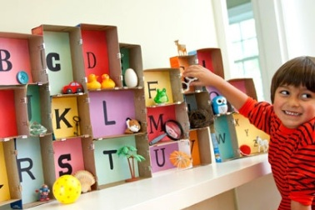 | Shoe boxes  Colored paper  Clips  Small items  Alphabet (odd puzzle pieces, random cards)
Letter Search and match – Hide magnetic letters in birdseed/sand table. Children find them and match to letters on magnetic chart. I used the back of my metal desk. Start with upper case and eventually add in lower case or pictures to match beginning sounds. | Balanced Literacy Diet  http://www.oise.utoronto.ca/balancedliteracydiet/Home/index.html | 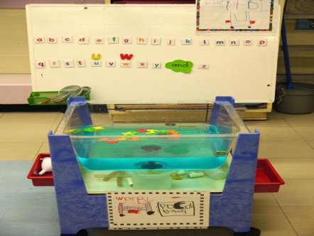 | Sand table/ water table  scoops  Magnetic letters  Alphabet chart  Pictures with beginning sounds.
Tack Letters – write letters/names on paper. Use a bulletin board or cardboard box. Kids put tacks in letters along lines. | Occupational Therapist |  | Paper  Tacks  Cardboard box  Bulletin board
Books – fiction and non-fiction alphabet books | Library and TRC |  | Chicka, Chicka, Boom Boom.  Alpha Ooops!
Letter Match – rocks with letters written on them. Paper/chart with poem (etc.) written in large writing.  Kids select a rock and find the matching letter on the chart. Cover letter with rock. | Web | 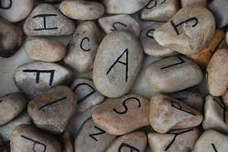

Writing Centre
Write and Wipe Letters/numbers  – students write name over the letter shapes  -could use name cards too  - students form and press wikki sticks on letters/numbers | Value Village | Laminated letters  White board markers  Wikki Sticks
Small chalk boards- could use chalk but just too dusty. Use water and small paint brushes or Q-tips. Write letter on chalk board and trace over with water. | Pinterest | Small chalk boards  Chalk  Wet cloth to wipe  Small paint brush  Q-tips  Water cup with water
Journals & writing tools |  | Unlined journal  Wax and pencil crayons  Markers  Stickers  Pencils
Christmas Wish List  Students cut out pictures of things they would like for Christmas or things they would like to get for their family or friends.  Health outcome – I am more than my physical self |  | Christmas Catalogues/magazines/flyers  Scissors  Paper  Glue  Writing tools  Sheet that starts out:  Dear _________,

Science/Social Weather Centre
Dress Me For the Weather Paper Dolls | http://www.makingfriends.com/friends/f_seasonal.htm |  | Laminated paper dolls  Laminated paper clothing
Weather report | Teacher’s Trunk or printables from  Pinterest |  | Laminated magnetic weather signs such as:  Sun, Wind, Rain, Clouds,  Rainbow, Snowflakes, Thermometer, Numbers
Weather related books  Froggy gets Dressed- story sack  Thomas’s Snowsuit  The Mitten  The Hat  Snowmen at Night  The Story of Snow  Animals in Winter  http://www.readingconfetti.com/2013/01/25-winter-books-and-crafts-for-kids.html  for these 25 books  Can be read at Circle Time and the craft can be set up as an invitation at the Craft Centre. | P.A. Literacy  School Library  Public Library  TRC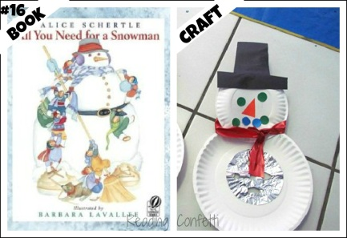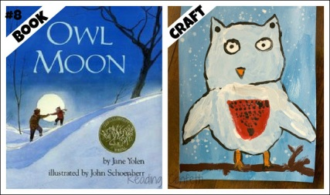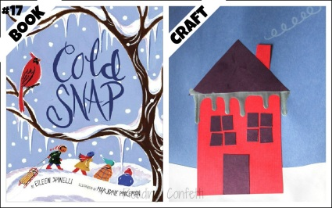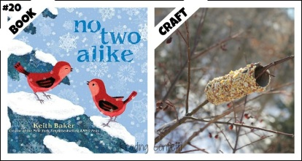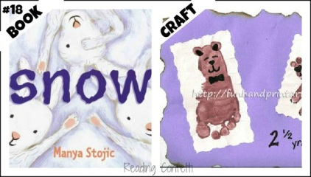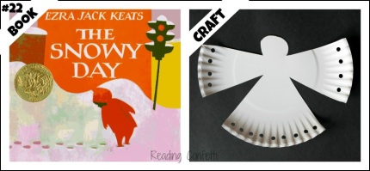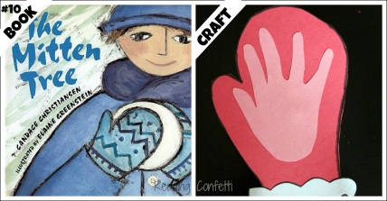 | 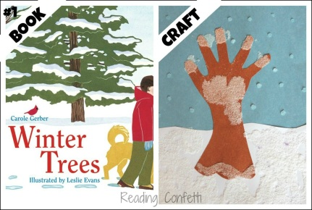  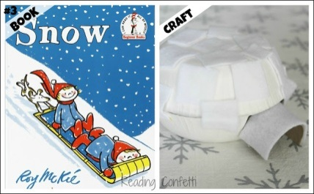  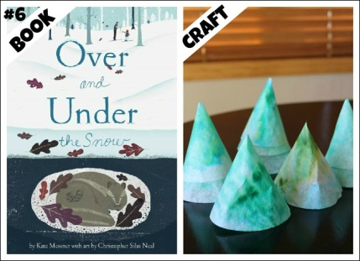  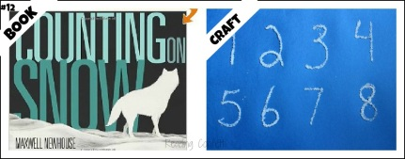  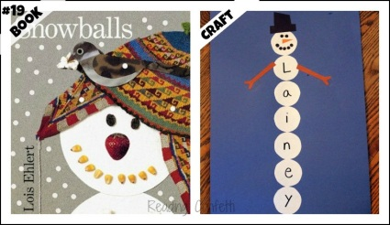  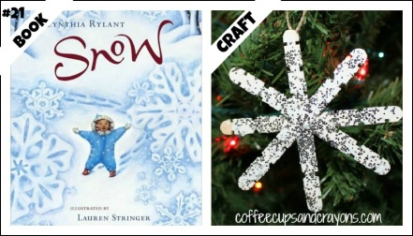  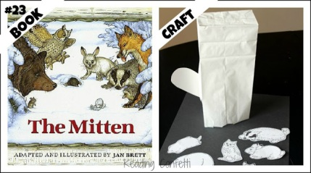 | 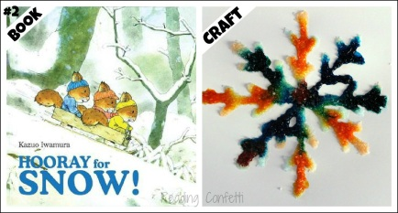  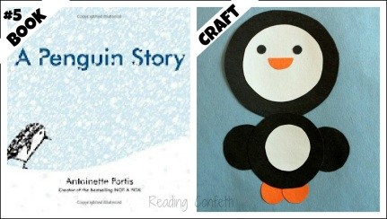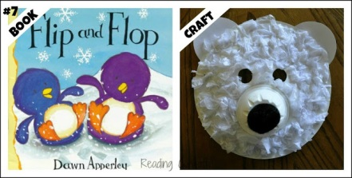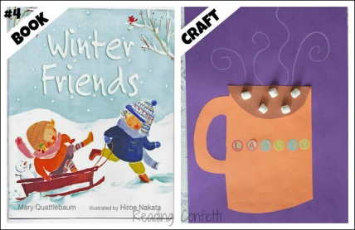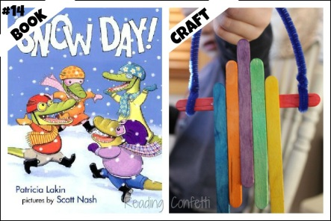  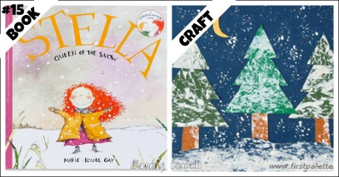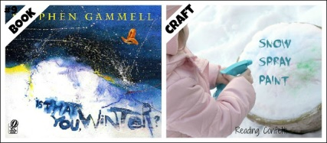  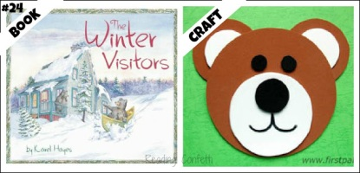
Music Centre
- Variety of real and homemade musical instruments. Too noisy for indoors? Take it outside.
  - Shakers (homemade and found)
  - Bongos and coffee can drums
  - wind chimes
  - Ukulele
  - Kazoo’s
- Books Library and/or TRC
- Sheet music

Math Centre
- Counting Games - Teacher made and purchased
  - Sneaky Snacky Squirrel
  - Shelby’s Snack Shack
  - Snakes and Ladders
  - # matching games
  - Magnetic numbers with small items to build sets
- Math related commercial books and class made books

Craft Centre/ Painting Centre
- Using the books from circle time as inspiration for craft centre
- Craft idea books
- Labels on supplies
Puzzle & Game Centre
- Variety of alphabet/number puzzles
- Alphabet Fishing Game
Dramatic Play Centre
- Kitchen play centre with dress up clothes.
- Puppets at reading centre.
- Most of the drama work will happen at circle time as a group
- Fliers and labels
- Recipe books
- Menus
- Phone book
Reading Centre
- Variety of fiction and non-fiction books
- Newspapers
- Magazines
- Comic books
Building Centre
- Building supplies of all sizes
- Blue prints or photos of possible constructions
- labels
Table Top Centre
- labels
- pictures of previous students work
Water Table
- Snow, ice and water
- Scoops, shovels, cups, etc.
- Igloos
- People/animals

